Scoil Ruáin, Killenaule

WHOLE SCHOOL GUIDANCE PLAN

Policy Area | Schools
Document Reference Number | SC.R/WSGP/046/0
Version No. | 1
Document Drafted by | Scoil Ruáin Killenaule
Date previous version adopted by TETB | N/A
Date Reviewed/Amended by School | February, 2021
Date Reviewed / Ratified by Senior Management Team – CE and Directors | 4th March, 2021
Date (Review/Amendment) noted by TETB | 23rd March, 2021
Date of Withdrawal of Obsolete Document | N/A  Document Ref. No. -  Version No. -

Scoil Ruáin Whole School Guidance Plan
Section A: Statement of Guidance Policy

- Introductory statement
“Guidance-related learning builds on children’s holistic education which starts in early childhood education… dispositions, attitudes and values, skills, knowledge, and understanding.” In Scoil Ruáin, guidance is delivered by the guidance counsellor in collaboration with the teaching staff and management of the school, the partners in education, and external organisations. Guidance is a whole school activity.
This guidance plan was formulated after attending the whole school guidance planning conference in May 2019, and two follow up meetings in Scoil Ruáin in November and December 2019.

- Scope
Developing Myself | - Developing & maintaining self-esteem & a positive self-concept  - Interacting effectively with others (face-to-face & online)  - Developing & growing throughout life
Developing My Learning | - Employing effective personal learning/exam strategies  - Making educational choices in line with career aspirations
Developing My Career Path | - Using career related information & sources appropriately  - Understanding the world of work & life roles  - Managing career development & decision making
Guidance concerns itself with three areas of learning, and eight competencies, as follows:

Guidance activities and the relevant personnel are summarised in the attached Whole School Guidance Continuum.

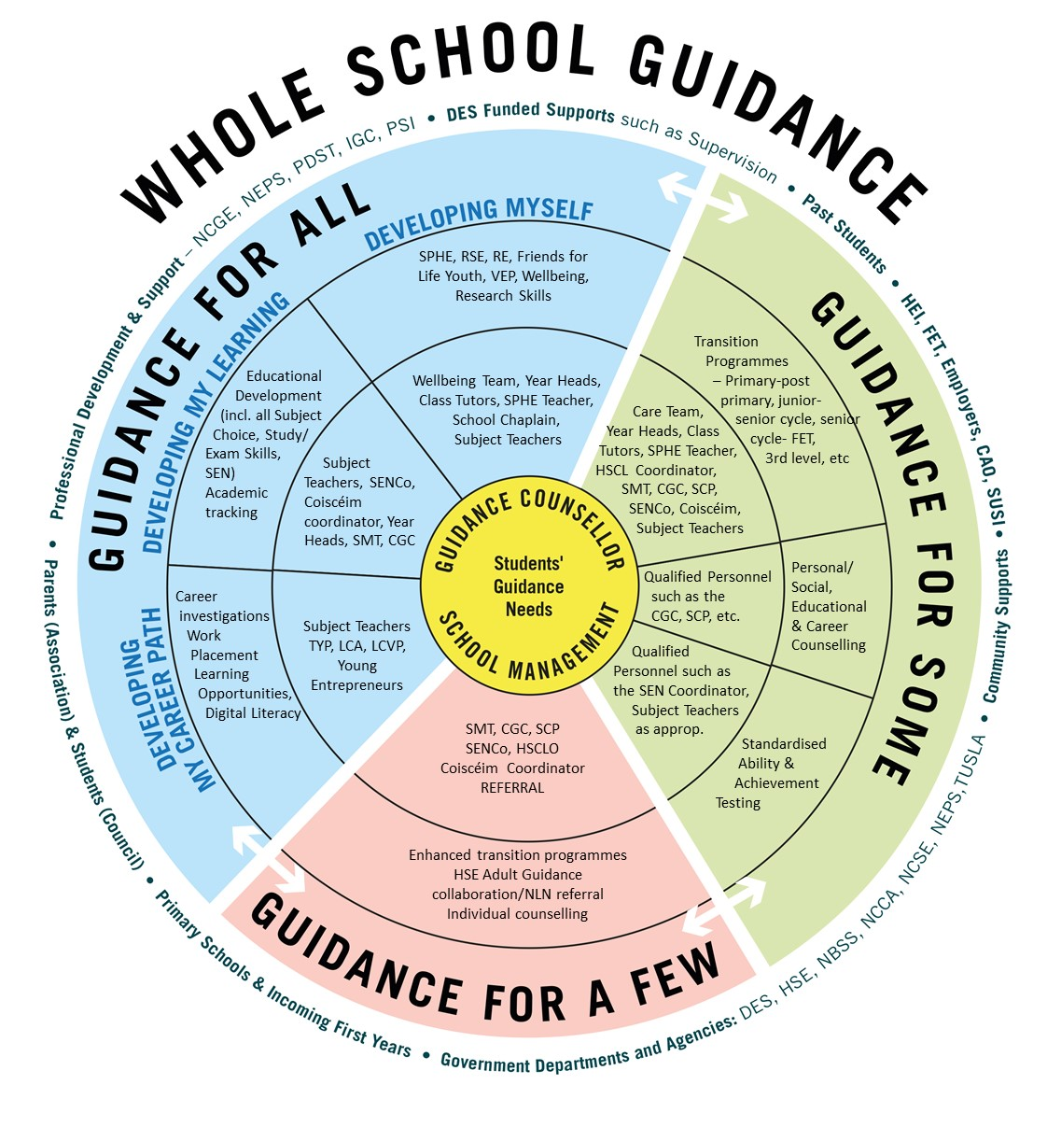

- Rationale
Legislative and policy framework:
- Education Act 1998
- National Skills Strategy 2025
- Action plan for Education 2019
- Action plan for Jobs 2018
- Further Education and Training Strategy 2014-2019
- National Plan for Equity of Access to Higher Education 2015-2019
- National Strategy for Higher Education 2030
- An International Education Strategy for Ireland, 2016-2020
We recognise the need to provide appropriate guidance that meets the needs of all students.

- Relationship to the characteristic spirit of the school
Mission Statement: Scoil Ruáin will provide a quality education in a caring, respectful and nurturing environment. We will encourage the development of the complete person in keeping with our school motto “Ad totam Personam”.

- Goals and aims

The aims of guidance in Scoil Ruáin:
- To include all students
- To support student transition from primary to post-primary education, from junior to senior cycle, and from senior cycle to employment, FET, or third level education.
- To guide students in identifying their strengths and aptitudes
- To enable students become independent learners and support them in achieving their potential in the next phase of their lives
- To facilitate students in making informed, realistic choices.
- To provide enhanced support for students with additional needs, in line with the continuum of support.

The aims of this guidance plan:
- To tie together all the strands of guidance and promote the idea that guidance is a whole school activity and the responsibility of every member of the school community.
- To document guidance provision that reflects the needs of junior and senior students.

Section B: Guidance Programme
Key Measures
 | Activity | Calendar | Timetabled | Extra-curricular | CGC specific | Parent  Involvement | Staff involved
Transition from primary to post-primary | Open night | Oct/ Nov |  |  |  | X | All
 | Primary school visit (principal) | Oct |  |  |  |  | Principal/Deputy
 | Subject taster days for primary school | Nov |  |  |  |  | Primary school liaison teacher
 | Entrance Tests & parent information session | Feb/ Mar |  |  |  | X | Principal/Deputy/Year Head/SENCo/CGC/HSCLO
 | Primary school visit (HSCLO/SENCo) | May |  |  |  |  | HSCLO/SENCo
 | Education passport | Jun |  |  |  | X | Primary school/ hsclo/SENCo
All junior students | RSE | Ongoing | X |  |  |  | SPHE teacher
 | SPHE |  | X |  |  |  | SPHE teacher
 | Wellbeing |  | X |  |  |  | Wellbeing teachers
 | RE |  | X |  |  |  | RE teacher
 | PE |  | X |  |  |  | PE teachers
 | CSPE |  | X |  |  |  | CSPE teachers
 | DEAR | Oct/  Jan | X |  |  |  | All
 | Academic tracking/ standardised testing | Ongoing |  |  |  |  | Principal/Deputy/Year Heads/SENCo/All
 | SEN support | Ongoing |  |  |  |  | SENCo/Coiscéim/All
 | Reports | Dec/  May |  |  |  | X | All
 | Referrals to external agencies as appropriate | Ongoing |  |  | X |  | Principal/Deputy/CGC/SENCo/ Coiscéim
 | Prize-giving to acknowledge achievement | May |  |  |  |  | All
First year | Celebration night | Oct/  Nov |  | X |  | X | All/RE teacher
 | Subject tasters | Ongoing | X |  |  |  | Specialist teachers
 | Literacy/numeracy initiatives | Ongoing | X |  |  |  | All
 | Parent teacher meeting | Mar |  |  |  | X | All
 | Subject selection meeting | Apr/ May |  |  | X | X | Principal/Deputy/CGC
 | VS ware access  Behaviour  Attendance  Results | Ongoing |  |  |  | X | All
 | Sport/competitions  e.g., hurling, basketball, annual 5K run |  | X | X |  |  | Coaches
 | Cultural activities  e.g., poetry aloud, storyteller, JCSP initiatives |  | X | X |  |  | All
 | Business activities  e.g., young entrepreneurs, Christmas market | Dec/ Mar |  | X |  |  | Business teachers
 | Sports day/ trip | May |  | X |  |  | PE teachers/year heads
 | Study skills | Ongoing | X |  | X |  | CGC/SENCo/SPHE/wellbeing teachers
 | Research skills |  | X |  |  |  | CGC/SENCo/SPHE/wellbeing teachers
 | Vocabulary Enrichment Programme |  | X |  |  |  | SENCo
 | Individual Counselling |  |  |  | X |  | CGC
Second year | VS ware access  Behaviour  Attendance  Results |  |  |  |  |  | All
 | Sport/competitions  e.g., hurling, basketball, annual 5K run |  | X | X |  |  | All
 | Cultural activities  e.g., poetry aloud, storyteller, JCSP initiatives |  | X | X |  |  | All
 | Uptake of optional subjects |  | X |  |  |  | All
 | Friend for Life: My Friends Youth |  | X |  |  |  | Friends for Life teachers
 | Short courses: ESS & PE |  | X |  |  |  | Subject teachers
 | Team-teaching |  | X |  |  |  | Support teachers
 | CBAs & SLAR meetings | Jan-May |  |  |  |  | All
 | Parent-teacher meeting | Feb |  |  |  | X | All
 | Trip abroad to Barcelona | May |  | X |  |  | Trip co-ordinator/Support teachers/SNA
 | L2LP registration | Ongoing |  |  |  |  | JCPA coordinator
 | Individual Counselling |  |  |  | X |  | CGC
Third Year | VS ware access  Behaviour  Attendance  Results
 | Sport/competitions  e.g., hurling, basketball, annual 5K run |  | X | X
 | Cultural activities  e.g., poetry aloud, storyteller, JCSP initiatives |  | X | X
 | Term assessment | Nov |  |  |  |  | All
 | Parent-teacher meeting | Dec |  |  |  |  | All
 | Pre-exams | Jan-Feb |  |  |  |  | All
 | Information evening on subject options and programmes | Feb |  |  |  |  | Principal/Deputy
 | Programme/subject selection meetings | Mar |  |  |  |  | Principal/Deputy/CGC
 | Interviews for TY/LCA | Mar |  |  |  |  | External interviewer
 | CBA & SLAR meetings | Nov-Apr |  |  |  |  | All
All senior students | RSE | Ongoing | X |  |  |  | Subject teachers
 | SPHE |  | X |  |  |  | Subject teachers
 | RE |  | X |  |  |  | Subject teachers
 | PE |  | X |  |  |  | Subject teachers
 | Careers |  | X |  | X |  | CGC
 | DEAR | Oct |  |  |  |  | All
 | Academic tracking | Ongoing |  |  |  |  | Principal/Deputy/Year Heads/SENCo/All
 | SEN support |  |  |  |  |  | SEN team
 | Reports | Dec/ May |  |  |  |  | All
 | Referrals to external agencies as appropriate | Ongoing |  |  | X |  | Principal/Deputy/CGC/SENCo/ Coiscéim
 | Prize-giving to acknowledge achievement | May |  | X |  |  | All
 | Individual Counselling | Ongoing |  |  | X |  | CGC
TY | Induction day | Sep |  |  |  |  | TY coordinator
 | Portfolio (incl. career investigation) | Ongoing |  |  |  |  | TY coordinator/all
 | SPHE |  | X
 | Variety of independent activities e.g., recycling, exam aides, etc... |  |  | X |  |  | All
 | Baby simulators | Nov-Mar |  | X |  |  | TY coordinator
 | Musical production | Oct-Nov |  | X |  |  | TY coordinator/Support staff
 | Careers Expo | Oct |  |  |  |  | CGC/support staff
 | CAT 4 with LC indicators | Dec |  |  |  |  | CGC/Senco
 | Voluntary work e.g., Lourdes, Hope Foundation, OAP party | Ongoing |  | X |  |  | TY coordinator/RE teacher
 | Work Experience | Jan/Mar | X |  |  |  | TY coordinator/CGC
 | Individual interviews about senior cycle choices | Mar |  |  |  |  | Principal/Deputy/CGC
 | Young Entrepreneurs | Dec |  | X |  |  | Business teachers
 | Gaisce | Ongoing |  | X |  |  | Gaisce coordinator
 | 2 night residential | Apr | X |  |  |  | TY coordinator
 | Graduation ceremony | May |  |  |  |  | TY coordinator
 | Individual counselling | Ongoing |  |  | X |  | CGC
Fifth year | CAT 4 for those who skipped TY | Dec |  |  |  |  | CGC/SENCo
 | Individual career guidance meetings, focus on subject levels and goals | Ongoing |  |  | X |  | CGC
 | Revised study plan for senior cycle | Ongoing | X |  |  |  | CGC/SPHE teacher
 | LCVP |  |  |  |  |  | Business teachers
 | LCA |  |  |  |  |  | LCA coordinator/All
 | Careers Expo | Oct/ Nov |  |  |  |  | CGC
 | LCVP work experience |  |  |  |  |  | Programmes coordinator/business teachers
 | Visiting speakers from third level | Ongoing |  | X |  |  | CGC
 | Intro to Qualifax, CAO and careers portal as well as university website |  | X |  |  |  | CGC
 | Complete interest inventory |  | X |  |  |  | CGC
 | Godolphin interview techniques and motivational speakers |  |  | X |  |  | Programmes coordinator/business teacher
 | Individual counselling |  |  |  |  |  | CGC
LCA 1 | Tasks |  | X |  |  |  | All
 | Key assignments |  | X |  |  |  | All
 | Careers Expo |  |  | X |  |  | CGC
 | Weekly work experience |  | X |  |  |  | Programmes coordinator/LCA coordinator
 | Safepass |  |  | X |  |  | LCA coordinator
 | Manual Handling |  |  | X |  |  | LCA coordinator
 | Vocational Prep (incl. Interview techniques, etc...) | X |  |  | X |  | CGC
Sixth year | CAO filling | Nov-Jan |  |  |  |  | CGC
 | CAO late application | Feb-Jun |  |  |  |  | CGC
 | DARE/HEAR applications | Jan-Mar |  |  |  |  | CGC/SENCo
 | Careers Expo | Oct/ Nov |  | X | X |  | CGC
 | Advice on scholarships, accommodation, etc… for third level | Ongoing | X |  |  |  | CGC/SPHE teacher
 | Visiting speakers |  |  | X |  |  | Programmes coordinator
 | Attending university open days |  |  | X |  |  | CGC
 | Godolphin and Camida scholarship interviews |  |  | X |  |  | Programmes coordinator/business teacher
 | Parent teacher meeting | Oct/ Mar |  |  |  | X | All
 | Graduation ceremony | May |  |  |  | X | All
 | Individual Counselling | Ongoing |  |  |  |  | CGC
LCA 2 | Tasks |  | X |  |  |  | All
 | Key assignments |  | X |  |  |  | Subject teachers
 | Careers Expo |  |  |  | X |  | CGC
 | Safepass |  |  | X |  |  | LCA coordinator
 | Manual Handling |  |  | X |  |  | LCA coordinator
 | Visit to Archerstown FET |  | X |  |  |  | CGC/LCA coordinator
 | Vocational Prep | X |  |  |  |  | CGC
 | Personal Achievement Task | Ongoing |  |  |  |  | LCA coordinator
 | Graduation ceremony | May |  |  |  | X | All

Section C: Guidance Resources
Documents:
- Whole School Guidance template
- Whole School Guidance Framework
- Whole School Guidance Framework Pilot 2017-2019
Personnel
- Principal
- Deputy Principal
- Career Guidance Counsellors
- SEN co-ordinator
- Coiscéim co-ordinator
- Home School Community Liaison Officer
- School Completion Officer
- All teaching staff
Materials and facilities
- Chromebooks
- Access to computer room
- Cognitive abilities tests
- Admissions information from third level institutions
- Room 10
- CGC office
Section D: Areas for development
- Increasing uptake of volunteer work
- Documenting progression of students after post-primary
- Increased parent voice and focus groups for partners in education
- Careers talks from employers and parents as well as university admissions officers
- Increase student voice
- Supporting students who do not choose to progress to third level.

Appendix 1: School Teams

Senior Management  - Principal: James Williams  - Deputy Principal: Siobhan Landers  - Programmes co-ordinator: Joan Costigan  - AP1s:  - Sean O’Regan  - Elaine Shine  - Gerry Treacy  - Gerry Maguire  - Gráinne Molony  - Jane O Connor (acting) | Year Heads  - Gerry Maguire  - Gerry Treacy  - Siobhan Tobin  - Breeda O’Neill  - Claire Gubbins  - Paul White  - Sean O Regan
AP2s  - Claire Gubbins  - Vincent O’Dwyer  - Breeda O’Neill  - Siobhan Tobin  - Francis Kearney  - Bridget Carpenter | SEN  - Breda Dwyer  - Jane O’Connor  - Rhea Smith  - Laura Jordan  - Margaret O’Neill  - Paula Tobin Gleeson  - Marie Sheehan
Critical Incident Management Team  - James Williams  - Siobhan Landers  - Jane O’Connor  - Joan Costigan  - Sean O’Regan  - Gráinne Molony/Elaine Shine  - Roisin Slattery  - Lucy Butler | Student support/Care team  - James Williams  - Siobhan Lander  - Joan Costigan  - Jane O’Connor  - Roisin Slattery  - Breda Dwyer  - Grainne Molony/Elaine Shine
Guidance Team  - Joan Costigan  - James Williams  - Siobhan Landers  - Grainne Molony/Elaine Shine  - Breda Dwyer  - Gerry Maguire  - Breeda O’Neill  - Jane O’Connor  - Roisin Slattery | DEIS  - Grainne Molony/Elaine Shine*  - Siobhan Landers  - Jane O’Connor  - Joan Costigan  - Roisin Slattery  Elaine Shine – acting HSCLO

Appendix 2: Relevant policies

Antibullying
Child protection
One-to-one meetings
Work experience
Transition Year admission
Leaving Cert Applied admission
School Trips
SEN policy
RSE policy

NCGE: A Whole School Guidance Framework, June 2017, p15
NCGE: A Whole School Guidance Framework, June 2017, p16
https://www.euroguidance.eu/guidance-system-in-ireland
https://www.education.ie/en/Schools-Colleges/Information/Post-Primary-School-Policies/spp_template_guidance.doc
https://www.ncge.ie/school-guidance-handbook/ncge-whole-school-guidance-framework
https://www.ncge.ie/sites/default/files/NN49-Post%20Primary-WSG%20framework.pdf

